PRINCIPLES OF DATA SCIENCE

HARISHKUMAR ID 241801086
EXP1:DATA PREPROCESSING AND CLEANING

Learning Objectives
The objective of this experiment is to learn how to load and preprocess a customer churn dataset using Python. It also aims to understand how to clean the data by handling missing values and duplicate records, encode categorical variables, standardize numerical features, and perform Exploratory Data Analysis (EDA) using various statistical and graphical techniques

Libraries Used
This experiment uses the Pandas library for data loading and preprocessing, Matplotlib and Seaborn for creating visualizations, LabelEncoder from Scikit-learn to convert categorical data into numerical values, and StandardScaler to normalize numerical features before analysis.

Code:

# Step 1: Import Libraries import pandas as pd import matplotlib.pyplot as plt import seaborn as sns

from sklearn.preprocessing import LabelEncoder, StandardScaler

# Step 2: Load Dataset
df = pd.read_csv("C:\\Users\\Shyam
Ganesh\\Downloads\\archive\\customer_churn_dataset-testing-master.csv")

# Remove extra spaces from column names df.columns = df.columns.str.strip() print("First 10 Records") print(df.head(10))

print("\nLast 10 Records") print(df.tail(10))

print("\nShape of Dataset") print(df.shape)

print("\nColumn Names") print(df.columns.tolist())

# Step 3: Explore Dataset print("\nDataset Information") df.info()

print("\nSummary Statistics") print(df.describe(include="all"))

print("\nMissing Values") print(df.isnull().sum())

print("\nDuplicate Records") print(df.duplicated().sum())

# Step 4: Data Cleaning

# Remove duplicate records df.drop_duplicates(inplace=True)

# Convert TotalCharges to numeric (if available) if "TotalCharges" in df.columns:
df["TotalCharges"] = pd.to_numeric(df["TotalCharges"], errors="coerce")

# Replace missing values for col in df.columns: if df[col].dtype == "object":
df[col].fillna(df[col].mode()[0], inplace=True) else:
df[col].fillna(df[col].median(), inplace=True)

print("\nMissing Values After Cleaning") print(df.isnull().sum())

# Step 5: Encode Categorical Columns encoder = LabelEncoder()

categorical_columns = [
"gender",
"Partner",
"Dependents",
"Contract",
"PaymentMethod",
"InternetService",
"Churn"
]

for col in categorical_columns: if col in df.columns:
df[col] = encoder.fit_transform(df[col])

# Step 6: Standardize Numerical Features scaler = StandardScaler()

numerical_columns = []

for col in ["tenure", "MonthlyCharges", "TotalCharges"]: if col in df.columns:
numerical_columns.append(col)

if len(numerical_columns) > 0:
df[numerical_columns] = scaler.fit_transform(df[numerical_columns])

# Step 7: Distribution of MonthlyCharges if "MonthlyCharges" in df.columns: plt.figure(figsize=(6,4)) sns.histplot(df["MonthlyCharges"], kde=True) plt.title("Distribution of MonthlyCharges") plt.show()

# Distribution of Tenure if "tenure" in df.columns: plt.figure(figsize=(6,4)) sns.histplot(df["tenure"], kde=True) plt.title("Distribution of Tenure") plt.show()

# Step 8: Count Plot (Contract vs Churn) if "Contract" in df.columns and "Churn" in df.columns: plt.figure(figsize=(6,4)) sns.countplot(x="Contract", hue="Churn", data=df) plt.title("Contract vs Churn") plt.show()

# Step 9: Box Plot (MonthlyCharges vs Churn) if "MonthlyCharges" in df.columns and "Churn" in df.columns: plt.figure(figsize=(6,4)) sns.boxplot(x="Churn", y="MonthlyCharges", data=df) plt.title("MonthlyCharges by Churn") plt.show()

# Step 10: Correlation Heatmap plt.figure(figsize=(10,8)) sns.heatmap(df.corr(numeric_only=True), annot=True, cmap="coolwarm") plt.title("Correlation Heatmap") plt.show()

OUTPUT:

First 10 Records
CustomerID Age Gender Tenure Usage Frequency Support Calls \
- 1 22 Female 25 14 4
- 2 41 Female 28 28 7
- 3 47 Male 27 10 2
- 4 35 Male 9 12 5
- 5 53 Female 58 24 9
- 6 30 Male 41 14 10
- 7 47 Female 37 15 9
- 8 54 Female 36 11 0
- 9 36 Male 20 5 10
- 10 65 Male 8 4 2

Payment Delay Subscription Type Contract Length Total Spend \
- 27 Basic Monthly 598
- 13 Standard Monthly 584
- 29 Premium Annual 757
- 17 Premium Quarterly 232
- 2 Standard Annual 533
- 10 Premium Monthly 500
- 28 Basic Quarterly 574
- 18 Standard Monthly 323
- 8 Basic Monthly 687
- 23 Basic Annual 995

Last Interaction Churn
- 9 1
- 20 0
- 21 0
- 18 0
- 18 0
- 29 0
- 14 1
- 16 0
- 8 0
- 10 0

Last 10 Records
CustomerID Age Gender Tenure Usage Frequency Support Calls \
- 64365 48 Female 36 22 4
- 64366 26 Female 54 24 2
- 64367 64 Male 30 27 9
- 64368 51 Male 47 17 10
- 64369 45 Male 3 1 5
- 64370 45 Female 33 12 6
- 64371 37 Male 6 1 5
- 64372 25 Male 39 14 8
- 64373 50 Female 18 19 7
- 64374 52 Female 45 15 9

Payment Delay Subscription Type Contract Length Total Spend \
- 22 Premium Annual 342
- 21 Basic Annual 165
- 28 Premium Annual 884
- 26 Basic Annual 544
- 11 Standard Annual 218
- 21 Basic Quarterly 947
- 22 Standard Annual 923
- 30 Premium Monthly 327
- 22 Standard Monthly 540 64373 25 Standard Monthly 696

Last Interaction Churn
- 9 1
- 23 1
- 21 1
- 24 1
- 15 1
- 14 1
- 9 1
- 20 1
- 13 1
- 22 1

Shape of Dataset
(64374, 12)

Column Names
['CustomerID', 'Age', 'Gender', 'Tenure', 'Usage Frequency', 'Support Calls', 'Payment
Delay', 'Subscription Type', 'Contract Length', 'Total Spend', 'Last Interaction', 'Churn']

Dataset Information
<class 'pandas.core.frame.DataFrame'>
RangeIndex: 64374 entries, 0 to 64373
Data columns (total 12 columns):
# Column Non-Null Count Dtype
--- ------ -------------- -----
- CustomerID 64374 non-null int64
- Age 64374 non-null int64
- Gender 64374 non-null object
- Tenure 64374 non-null int64
- Usage Frequency 64374 non-null int64
- Support Calls 64374 non-null int64
- Payment Delay 64374 non-null int64
- Subscription Type 64374 non-null object
- Contract Length 64374 non-null object
- Total Spend 64374 non-null int64
- Last Interaction 64374 non-null int64 11 Churn 64374 non-null int64 dtypes: int64(9), object(3) memory usage: 5.9+ MB

Summary Statistics
CustomerID Age Gender Tenure Usage Frequency \ count 64374.000000 64374.000000 64374 64374.000000 64374.000000
unique NaN NaN 2 NaN NaN top NaN NaN Female NaN NaN freq NaN NaN 34353 NaN NaN
mean 32187.500000 41.970982 NaN 31.994827 15.080234 std 18583.317451 13.924911 NaN 17.098234 8.816470 min 1.000000 18.000000 NaN 1.000000 1.000000
25% 16094.250000 30.000000 NaN 18.000000 7.000000
50% 32187.500000 42.000000 NaN 33.000000 15.000000 75% 48280.750000 54.000000 NaN 47.000000 23.000000 max 64374.000000 65.000000 NaN 60.000000 30.000000

Support Calls Payment Delay Subscription Type Contract Length \ count 64374.000000 64374.000000 64374 64374
unique NaN NaN 3 3 top NaN NaN Standard Monthly freq NaN NaN 21502 22130 mean 5.400690 17.133952 NaN NaN std 3.114005 8.852211 NaN NaN min 0.000000 0.000000 NaN NaN
25% 3.000000 10.000000 NaN NaN
50% 6.000000 19.000000 NaN NaN 75% 8.000000 25.000000 NaN NaN max 10.000000 30.000000 NaN NaN

Total Spend Last Interaction Churn count 64374.000000 64374.000000 64374.000000
unique NaN NaN NaN top NaN NaN NaN freq NaN NaN NaN
mean 541.023379 15.498850 0.473685 std 260.874809 8.638436 0.499311 min 100.000000 1.000000 0.000000
25% 313.000000 8.000000 0.000000
50% 534.000000 15.000000 0.000000
75% 768.000000 23.000000 1.000000
max 1000.000000 30.000000 1.000000

Missing Values
CustomerID 0
Age 0
Gender 0
Tenure 0
Usage Frequency 0
Support Calls 0
Payment Delay 0
Subscription Type 0
Contract Length 0
Total Spend 0
Last Interaction 0
Churn 0
dtype: int64

Duplicate Records
0
Missing Values After Cleaning
CustomerID 0
Age 0
Gender 0
Tenure 0
Usage Frequency 0
Support Calls 0
Payment Delay 0
Subscription Type 0
Contract Length 0
Total Spend 0
Last Interaction 0
Churn 0
dtype: int64
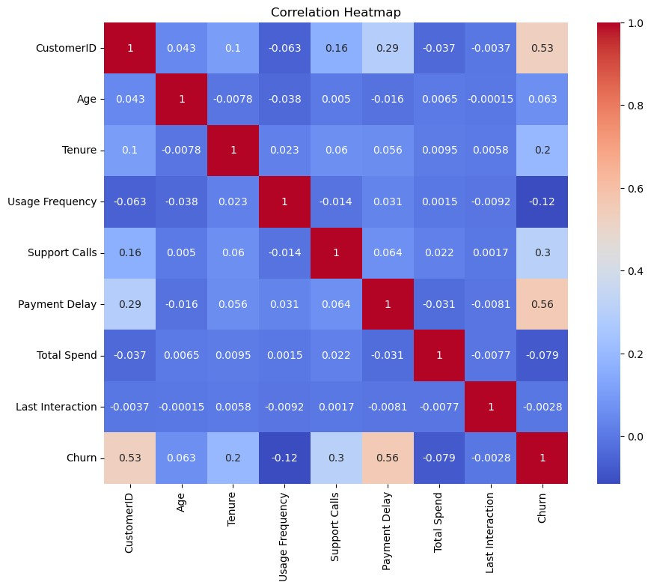

Learning Outcomes
After completing this experiment, students will be able to import and preprocess datasets efficiently, handle missing and duplicate data, encode categorical variables, standardize numerical features, create meaningful visualizations, analyze relationships between variables using a correlation heatmap, and prepare the dataset for further machine learning applications.

